Machine Problem 2(Python) Screenshots: 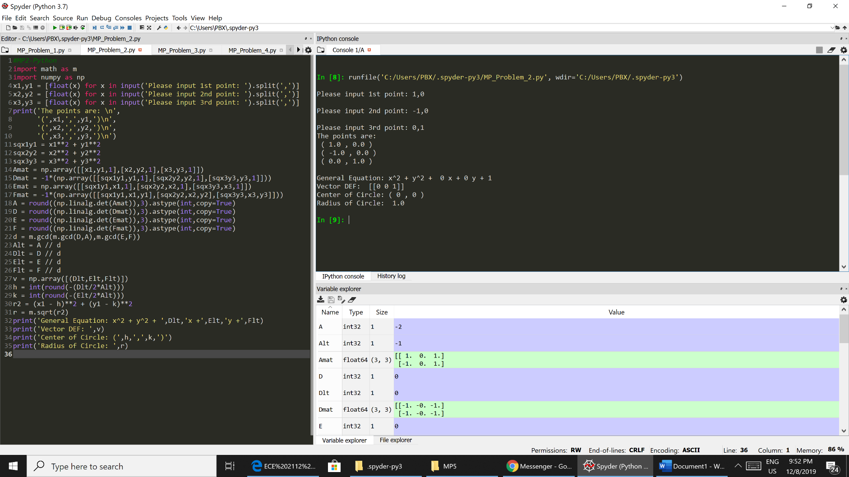

Picture 1 Code Testing with points (1,0),(-1,0),(0,1)

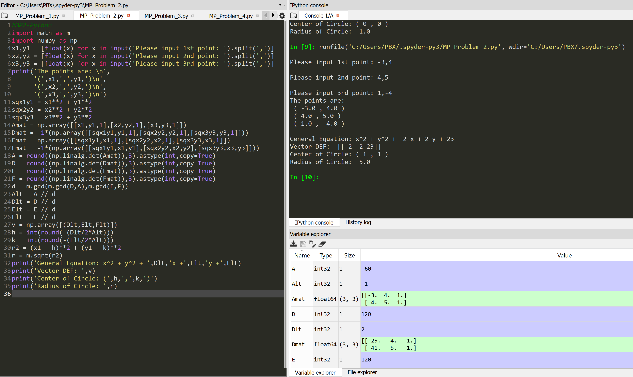

Picture 2 Code Testing with points (-3,4),(4,5),(1,-4)